Subject: Join Us for a Screening of the Documentary The Upstanders

Dear (Student Body/Community),

Join us for a...

Screening of the Documentary ‘The Upstanders’
Building Resilience and Empathy to stand against Cyber-bullying

Day, Date at XX:XX AM/PM
at (Registration Link)

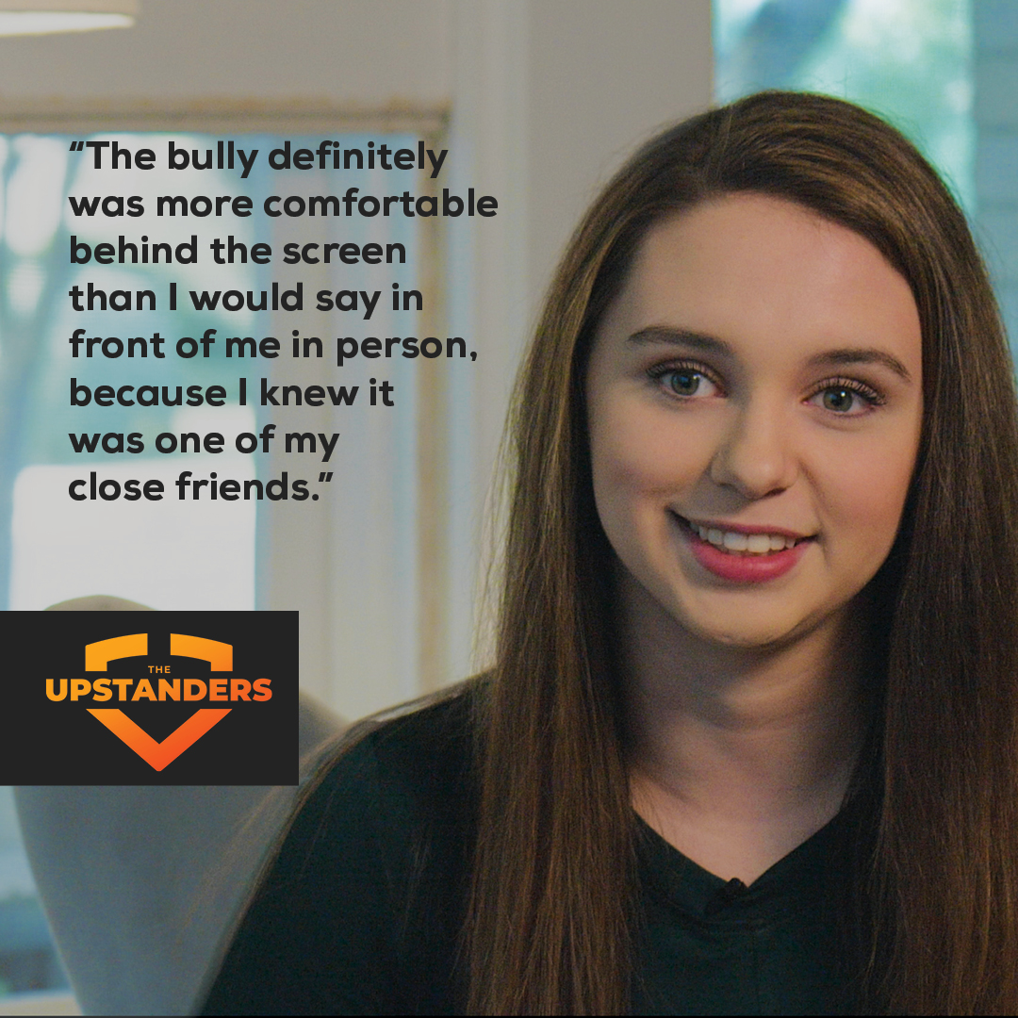

The Upstanders examines cyber-bullying from the perspectives of the bully, the victim and the onlooker, providing practical tips and resources to change the narrative – to stand up, speak out and support – and become an Upstander, not a Bystander

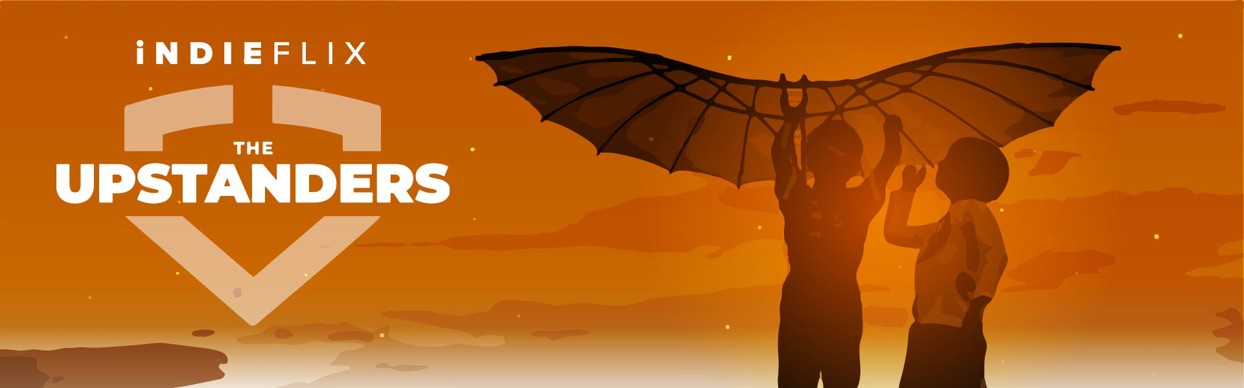

Post-film panel and discussion following the film.

Register to join us here:
(insert registration link)

Hope to see you there!

“I found David’s story to be very sad. It was really hard to hear the story. But if we turn away because it is hard to hear, then aren’t we just continuing to be bystanders. As hard as these stories are to hear, we need to stand up, listen, and speak out.” Abi M, Age 14

