Subject: Join Us for a Screening of Nevertheless

Dear

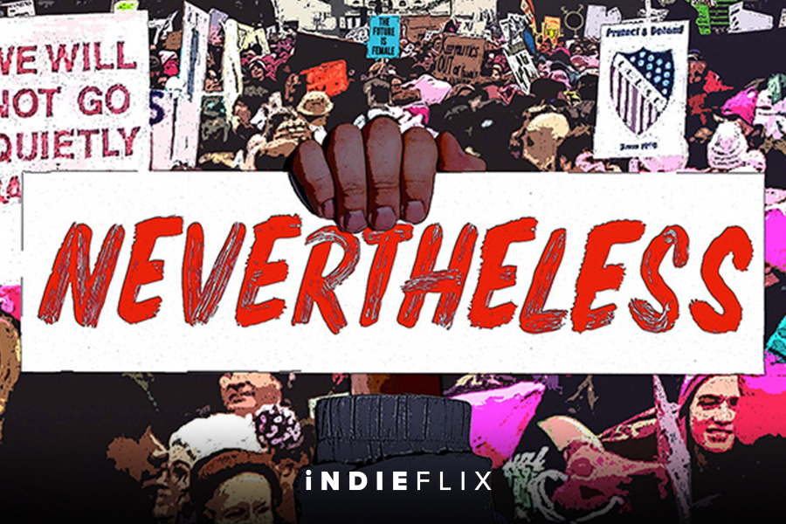

We’re looking forward to watching Nevertheless with you on
Day, Date at XX:XX AM/PM
(Insert Link)

This 50 / 80 minute documentary looks behind the headlines of #MeToo and Time’s Up, going back in time to understand the history of standing against harassment through the personal stories of both women and men. Hopeful and optimistic, it unites their narratives with expert perspectives, showing the importance of EVERYONE to shifting workplace culture, and ensuring greater equality for future generations. It will be well worth your time.

See you there!

