Subject: Join Us For a Screening of the Documentary LIKE

Dear (Student Body/Community),

Join us for a...

Screening of the Documentary ‘LIKE’
Understanding and Creating Balance in Social Media

Day, Date at XX:XX AM/PM
at (Registration Link)
Film plus discussion will last approx 90 minutes

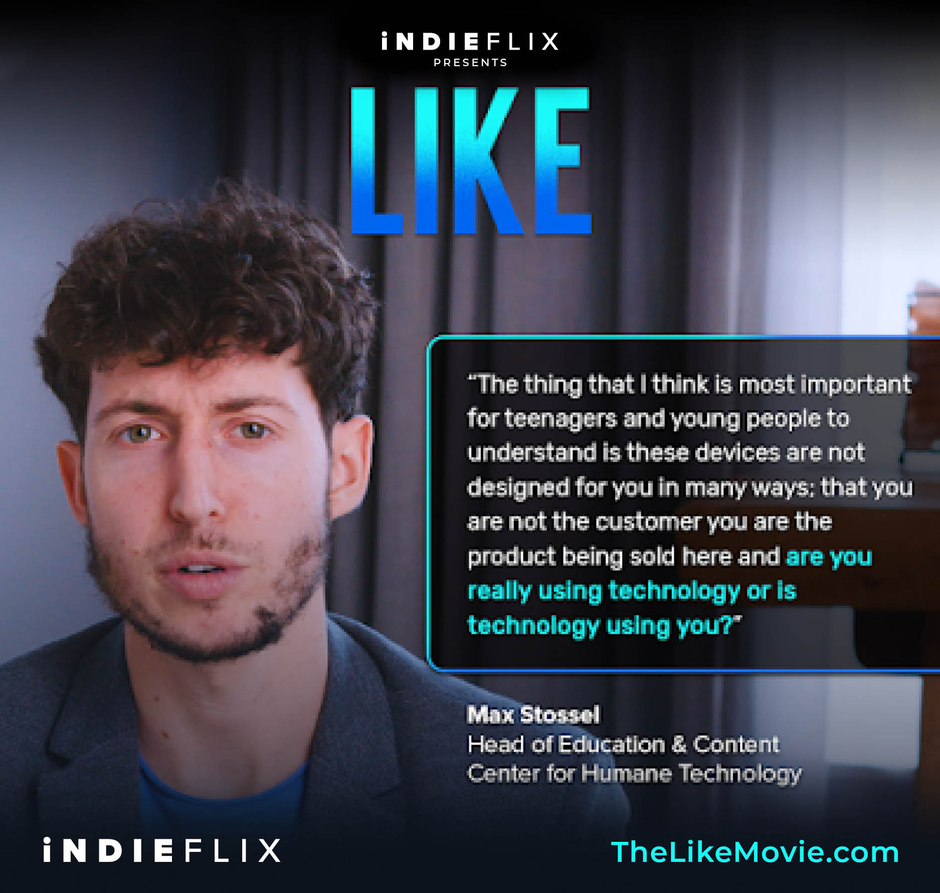

LIKE breaks down why we find social media so irresistible, examines who is controlling who, and gives you the tools to pivot to a more balanced and contented relationship. It features Silicon Valley entrepreneurs, including the co-creator of the ‘LIKE’ button, experts in brain science and regular teenagers

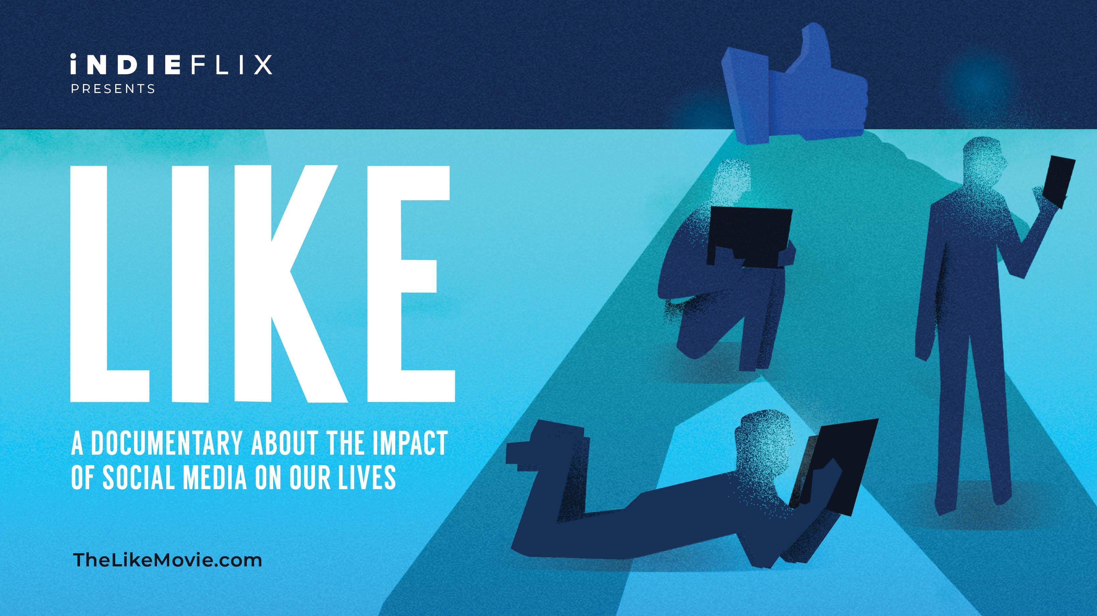

Includes a post-film panel discussion and Q&A.

Register to join us here: (registration link)

Looking forward to seeing you there!

“LIKE tells the real story behind social media platforms: you, all of us are the product. It also tells the positive aspects of social media. Having a balanced perspective on how to navigate social media platforms is essential to all parents and educators raising and educating this generation.”
Maria O Alvarez, VP Common Sense Latino

